

FACULTY OF ENGINEERING & TECHNOLOGY

**ASSIGNMENT REPORT ON APPLICATION OF KNOWLEDGE ACQUIRED FROM MODULES ONE TO THREE USING MATLAB**

PRESENTED TO: THE COMPUTER PROGRAMMING COURSE LECTURER  
MR. MASERUKA BENDICTO

By GROUP 18

# ABSTRACT

This report details a two-part MATLAB assignment focused on applying data handling and organization skills. The first exercise involved importing a dataset of IMDB-Movie-Data from a website called Kaggle.com , reading it into MATLAB script, and then using the script to process the data.

The script organized the data by year and exported it into a single Excel workbook with separate sheets for each year. The second exercise concentrated on structuring diverse data types by using a MATLAB script to collect various personal attributes such as name, age, and interests from each gruop member and storing them in a single, cohesive structural array variable. The project demonstrated fundamental skills in data handling, organization, and problem-solving within the MATLAB environment, providing practical experience in a complete data workflow.

**Table of Contents**

ABSTRACT ii

ACKNOWLEGEMENT iv

DECLARATION v

APPROVAL vi

Chapter 1: Introduction 1

Chapter 2: Exercise solutions 2

Exercise 1: Kaggle Dataset categorizing 2

A sample of the Output of variables from the structural arrays into one excel workbook and separate sheets 4

Exercise 2: Group Member Data Storage 5

Second Assignment; 8

Question One; 8

Question Two; 12

QUESTION TWO SOLUTION; 13

Chapter 3: Conclusion and Learning Experience 18

Chapter 4: References and Resources 19

# ACKNOWLEGEMENT

By the Grace of GOD we were able to work together as a group to complete the assignment and we acknowledge him for that.

We thank, Mr. Maseruka Ben our course lecturer for guiding us in this course which is a vital aspect for our engineering profession.

Appreciation goes to group members for the commitment and team spirit which simplified work and made it easy for us to complete the task and come up with this report.

# DECLARATION

We, Group 18 members hereby declare to the best of our knowledge, that this assignment report is a true record of our unending efforts in applying the knowledge we acquired from modules one through three. It is truly an original creation of our own and it has never been used by any other individual for any academic award in any learning institution.

**MEMBERS OF GROUP 18**

|  |  |  |  |  |
| --- | --- | --- | --- | --- |
|  | **NAME** | **REG NUMBER** | **PROGRAM** | **SIGN** |
| **1** | UHURU DENISH BRIAN | BU/UP/2024/3841 | WAR |  |
| **2** | TUMUHAISE SARAH | BU/UG/2024/2674 | AMI |  |
| **3** | MUKHOOLI ELIJAH | BU/UP/2024/2586 | MEB |  |
| **4** | OMARA PASCAL KELLY | BU/UP/2024/1063 | WAR |  |
| **5** | AUMA DIANA | BU/UP/2024/1020 | WAR |  |
| **6** | NANDAULA CATHERINE | BU/UP/2024/4322 | AMI |  |
| **7** | NABAWEESI CLAIRE | BU/UP/2024/1046 | WAR |  |
| **8** | ENAMU REAGAN EGIMU | BU/UG/2024/2672 | APE |  |
| **9** | NAKAWEESA LINNET | BU/UP/2024/4327 | APE |  |
| **10** | OLUK CHRISTIAN GLEN | BU/UP/2024/3842 | WAR |  |

# APPROVAL

This is to confirm that this report has been written and presented by Group 18, giving details of the assignment carried out.

Course Lecturer

|  |  |
| --- | --- |
| **Signature** | **_____________________________** |
| **Date** | **_____________________________** |
|  |  |

## Chapter 1: Introduction

This report provides a detailed overview of the two-part MATLAB assignment. The first exercise focused on data manipulation, specifically the process of importing a dataset from Kaggle, structuring it for analysis, and exporting it to an organized Excel workbook. The second exercise involved a more focused task of structuring heterogeneous data by storing a group of members' personal attributes into a single, cohesive variable. In the second assignment, question one required us to visualize the different parameters, patterns, trays and relationships from reference of a dataset imported from Kaggle. Question two required us to describe the different statistical characteristics in our previously collected data and then visualize them. In this assignment we were required to demonstrate fundamental skills in data handling, organization, using code within the MATLAB environment.

**First Assignment;**

**Exercise 1**

Retrieve a unique data set from kaggle.com in Excel format.  
Write a single MATLAB script to:

1. Read the dataset into MATLAB
2. Copy variables for each year
3. Display data for each year in separate tables
4. Convert the tables from (3) into structural arrays
5. Output the variables from the structural arrays into one excel workbook and separate sheets for data of each year with clear column headings

Exercise 2

Each group has different members from different backgrounds, home districts, religions , tribes, villages, Courses , interests , ages , names, and facial representations

Write a MATLAB code that can store each member’s attributes into a single variable. Ensure the code saves the variable.

## Chapter 2: Exercise solutions

### Exercise 1: Kaggle Dataset categorizing

The primary objective of this exercise was to create a MATLAB script suitable for handling an external dataset. Our approach was a three-step process:

#### Methodology

**Data Acquisition and Import:** We sourced a unique dataset from Kaggle in Excel format. The MATLAB script was designed to use a function to read the entire .csv file, ensuring all data was available for processing. Our exercise required that the data be of a variety containing a field for the year. We chose a dataset of IMDB-Movie-Data.

We imported the data in Excel in order to remove records with missing values and, remove records with uncoherent data as well.

Once the data was clean and usable, our next step was to import it into our MATLAB environment. For that we added the dataset file into our exercise folder for convenience purposes, read it to MATLAB and proceeded with further processing.

**Data Processing:** Our end task was to structure the data into separate years maintaining the structure of the individual years’ data while keeping each individual year separate. To do this we used the MATLAB script to access the field labelled “Year” and extract unique values. These are the different years that our data has, repeated across multiple records. For our next step, we utilized the loop feature of MATLAB to iterate over our dataset while extracting the records of data that match each of the unique years; for every unique year!

Once we had extracted records of the year of interest, we converted the resulting filtered table into a structural array; and added it to a worksheet in our target Excel workbook.   
At the end of the iteration, we had an Excel workbook with different sheets corresponding to different years of IMDB-Movie-Data.

This final step required the script to output the structured data back into a single Excel workbook. Using MATLAB's built-in functions, we created an Excel workbook and to achieve the separation of the worksheets we used a property called Sheet, and assigned the respective years as sheet names. This ensures the output is easy for a human to interpret.

Below is the code we used to write a script that would accomplish our intended task, we saved the “group18.mlx” script into our exercise folder and executed the script using the Run command in our MATLAB IDE.

In the code below;

mat represents a dataset retrieved from Kaggle.com

mats represents table to structural array

matst represents structural array to table

READING DATA FROMA TABLE

mat = readtable("IMDB-Movie-Data.xlsx","ReadVariableNames",true);

disp(mat);

PUTTING VARIABLE OF EACH YEAR INTO TABLE OF ITS OWN

mat2014 = mat(mat.Year==2014, :);

mat2016 = mat(mat.Year==2016, :);

mat2008 = mat(mat.Year==2008, :);

mat2013 = mat(mat.Year==2013, :);

mat2012 = mat(mat.Year==2012, :);

mat2010 = mat(mat.Year==2010, :);

mat2009 = mat(mat.Year==2009, :);

mat2011 = mat(mat.Year==2011, :);

mat2006 = mat(mat.Year==2006, :);

mat2007 = mat(mat.Year==2007, :);

CONVERTING THE TABLE ABOVE INTO STRUCTURAL ARRAY

mats2014 = table2struct(mat2014);

mats2016 = table2struct(mat2016);

mats2008 = table2struct(mat2008);

mats2013 = table2struct(mat2013);

mats2012 = table2struct(mat2012);

mats2010 = table2struct(mat2010);

mats2009 = table2struct(mat2009);

mats2011 = table2struct(mat2011);

mats2006 = table2struct(mat2006);

mats2007 = table2struct(mat2007);

PUTTING THE VARIABLE ABOVE IN EXCEL WORKBOOK

S_TABLE2014 = struct2table(mats2014);

S_TABLE2016 = struct2table(mats2016);

S_TABLE2008 = struct2table(mats2008);

S_TABLE2013 = struct2table(mats2013);

S_TABLE2012 = struct2table(mats2012);

S_TABLE2010 = struct2table(mats2010);

S_TABLE2009 = struct2table(mats2009);

S_TABLE2011 = struct2table(mats2011);

S_TABLE2006 = struct2table(mats2006);

S_TABLE2007 = struct2table(mats2007);

writetable(S_TABLE2007,"DATA.xlsx","Sheet","2007");

writetable(S_TABLE2011,"DATA.xlsx","Sheet","2011");

writetable(S_TABLE2006,"DATA.xlsx","Sheet","2006");

writetable(S_TABLE2014,"DATA.xlsx","Sheet","2014");

writetable(S_TABLE2008,"DATA.xlsx","Sheet","2008");

writetable(S_TABLE2009,"DATA.xlsx","Sheet","2009");

writetable(S_TABLE2013,"DATA.xlsx","Sheet","2013");

writetable(S_TABLE2012,"DATA.xlsx","Sheet","2012");

writetable(S_TABLE2016,"DATA.xlsx","Sheet","2016");

writetable(S_TABLE2010,"DATA.xlsx","Sheet","2010");

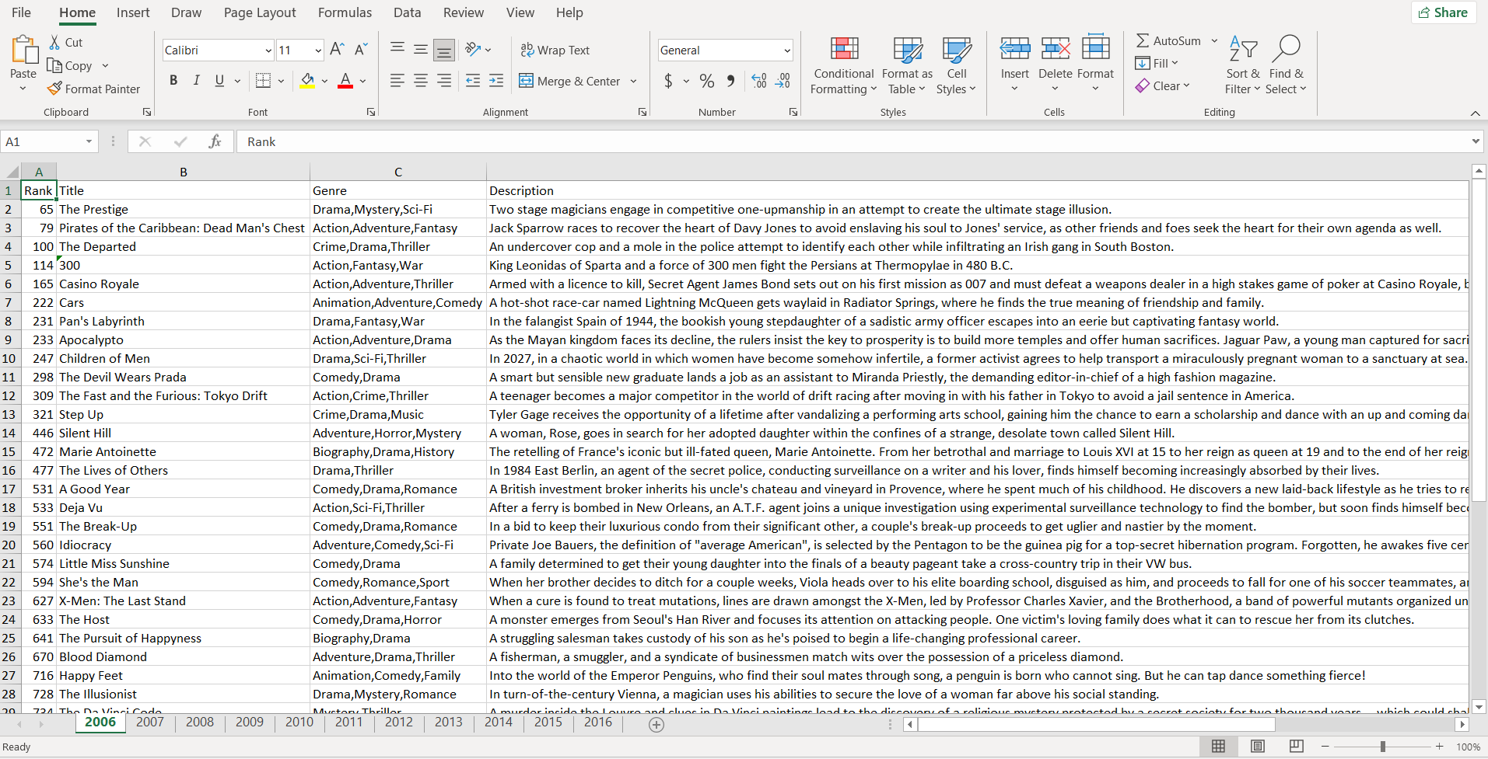

### A sample of the Output of variables from the structural arrays into one excel workbook and separate sheets

### Exercise 2: Group Member Data Storage

This exercise focused on a different aspect of data management: structuring varied data types into a single variable. The task was to take a set of attributes for each group member including home district, religion, tribe, interests, age, name, and a description for facial representation and store them collectively.

To accomplish this, we chose to utilize a structural array. Each element of the array represents a single group member, and each field within that element (e.g., .name, .age, .interests) holds the corresponding attribute. This approach allows for logical grouping of related data and simplifies future access and manipulation of the information.

Our main task here was to get the data into the MATLAB environment, for that we utilized the MATLAB input feature. Using a script, we prompted the user to enter values for the attributes of the different group members; again, we utilized a loop for this. First, we prompted the user to enter the group size, in terms of number of members; and iterated the attribute prompts for each of the members

Below is the code for the MATLAB script we used to achieve the intended outcome of the exercise.

%%Defining struct

members = struct('Name',{},'Age',{},'course',{},'HomeDistrict',{},'Interest',{},'Tribe',{},'Background',{},'FacialRepresentation',{},'Village',{},'Religion',{});

%member1

members(1).Name = 'MUKHOOLI ELIJAH';

members(1).Age = 28;

members(1).course = 'MEB';

members(1).HomeDistrict = 'Mbale';

members(1).Interest = 'Researching';

members(1).Tribe = 'Gishu';

members(1).Background = 'Humble';

members(1).FacialRepresentation = imread("IMG-20250907-WA0008.jpg");

members(1).Village = 'Bugema Cell';

members(1).Religion = 'Pentacostal';

%member2

members(2).Name = 'AUMA DIANA';

members(2).Age = 22;

members(2).course = 'WAR';

members(2).HomeDistrict = 'Oyam';

members(2).Interest = 'Watching';

members(2).Tribe = 'Lango';

members(2).Background = 'Humble';

members(2).FacialRepresentation = imread("IMG-20250911-WA0015.jpg");

members(2).Village = 'Aringolworo';

members(2).Religion = 'Catholic';

%member3

members(3).Name = 'UHURU BRIAN DENISH';

members(3).Age = 21;

members(3).course = 'WAR';

members(3).HomeDistrict = 'Lamwo';

members(3).Interest = 'Video Game';

members(3).Tribe = 'Acholi';

members(3).Background = 'Humble';

members(3).FacialRepresentation = imread("IMG-20250907-WA0008.jpg");

members(3).Village = 'Okokwene';

members(3).Religion = 'Catholic';

%member4

members(4).Name = 'TUMUHAISE SARAH';

members(4).Age = 21;

members(4).course = 'AMI';

members(4).HomeDistrict = 'Hoima';

members(4).Interest = 'Cooking';

members(4).Tribe = 'Runyoro';

members(4).Background = 'Humble';

members(4).FacialRepresentation = imread("IMG-20250911-WA0018.jpg");

members(4).Village = 'Katasiha';

members(4).Religion = 'Anglican';

%member5

members(5).Name = 'NABAWEESI CLAIRE';

members(5).Age = 20;

members(5).course = 'WAR';

members(5).HomeDistrict = 'Mityana';

members(5).Interest = 'Watching animations';

members(5).Tribe = 'Muganda';

members(5).Background = 'Humble';

members(5).FacialRepresentation = imread("IMG-20250907-WA0007.jpg");

members(5).Village = 'Wabigalo';

members(5).Religion = 'Catholic';

%member6

members(6).Name = 'NANDAULA CATHERINE';

members(6).Age = 21;

members(6).course = 'AMI';

members(6).HomeDistrict = 'Buvuma';

members(6).Interest = 'Baking';

members(6).Tribe = 'Muganda';

members(6).Background = 'Humble';

members(6).FacialRepresentation = imread("IMG-20250911-WA0010.jpg");

members(6).Village = 'Bugaya';

members(6).Religion = 'Bornagain';

%member7

members(7).Name = 'OMARA PASCHAL KELLY';

members(7).Age = 21;

members(7).course = 'WAR';

members(7).HomeDistrict = 'Oyam';

members(7).Interest = 'Singing';

members(7).Tribe = 'Lango';

members(7).Background = 'Humble';

members(7).FacialRepresentation = imread("IMG-20250911-WA0013.jpg");

members(7).Village = 'Aringoarum';

members(7).Religion = 'Catholic';

%member8

members(8).Name = 'ENAMU REAGAN EGIMU';

members(8).Age = 21;

members(8).course = 'APE';

members(8).HomeDistrict = 'Soroti';

members(8).Interest = 'Soccer';

members(8).Tribe = 'Itesot';

members(8).Background = 'Humble';

members(8).FacialRepresentation = imread("IMG-20250911-WA0007.jpg");

members(8).Village = 'Owalei';

members(8).Religion = 'Catholic';

%member9

members(9).Name = 'OLUK CHRISTIAN GLEN';

members(9).Age = 21;

members(9).course = 'WAR';

members(9).HomeDistrict = 'Apac';

members(9).Interest = 'Playing Football';

members(9).Tribe = 'Lango';

members(9).Background = 'Humble';

members(9).FacialRepresentation = imread("IMG-20250911-WA0017.jpg");

members(9).Village = 'Akokoro';

members(9).Religion = 'Catholic';

%member10

members(10).Name = 'NAKAWEESA LINNET';

members(10).Age = 21;

members(10).course = 'APE';

members(10).HomeDistrict = 'Mukono';

members(10).Interest = 'Food';

members(10).Tribe = 'Muganda';

members(10).Background = 'Humble';

members(10).FacialRepresentation = imread("IMG-20250911-WA0021.jpg");

members(10).Village = 'Mukono';

members(10).Religion = 'Bornagain';

save("test.mat","members")

# Second Assignment;

# Question One;

From the previous question one, utilize all knowledge obtained from module one to four to visualize the different parameters, patterns, trays and relationships.

Ensure that each plot is saved as an image and is well annotated ( labelled).

IN REFFERENCE TO THE CODES OF EXERCISE ONE IN THE FIRST ASSIGMENT;

VISUALIZATION OF THE DATA

1. HISTOGRAM

histogram(mat.Rating,50);

xlabel("RATING");

ylabel("FREQUENCY");

title("DISTRIBUTION");

grid on;

saveas(gcf,"figure 1 RATING.png");

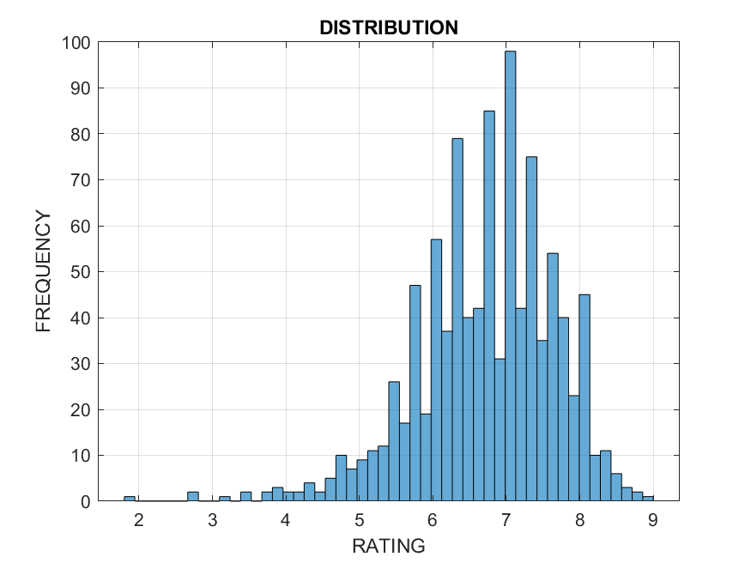

histogram(mat.Runtime_Minutes_);

title("Distribution of movie time");

xlabel("Runtime minutes");

ylabel("Frequency");

grid on;

saveas(gcf,"figure 2 RUNTIME_MINUTE.png")

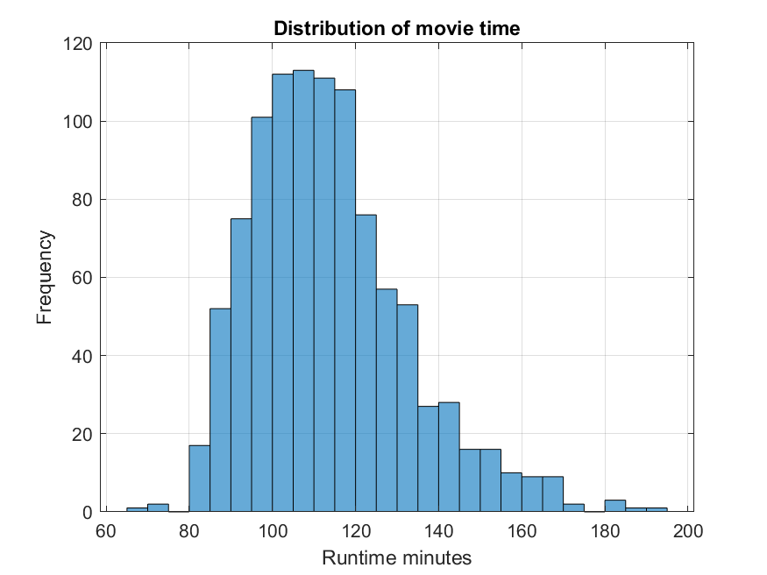

2. BAR GRAPH

TABLE2 = groupsummary(mat,"Year");

bar(TABLE2.Year,TABLE2.GroupCount,"g");

grid on;

title("MOVIES PRODUCED PER YEAR");

xlabel("YEAR");

ylabel("NUMBER OF MOVIES");

saveas(gcf,"figure 3 MOVIES.png");

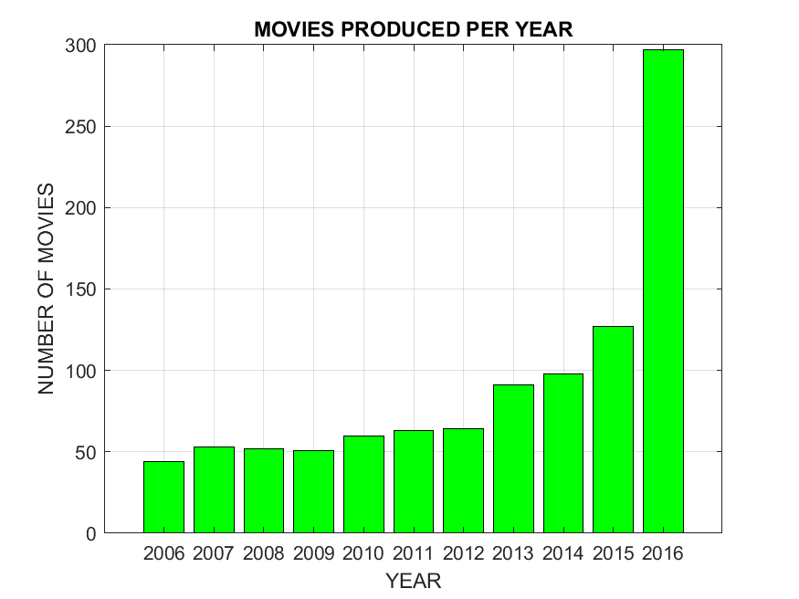

3. SCATTER DIAGRAM

scatter(mat.Votes,mat.Revenue_Millions_,"r","filled");

title("RATING Vs VOTE");

xlabel("VOTES");

ylabel("VOTES");

grid on;

saveas(gcf,"figure 4 SCATTER PLOT.png");

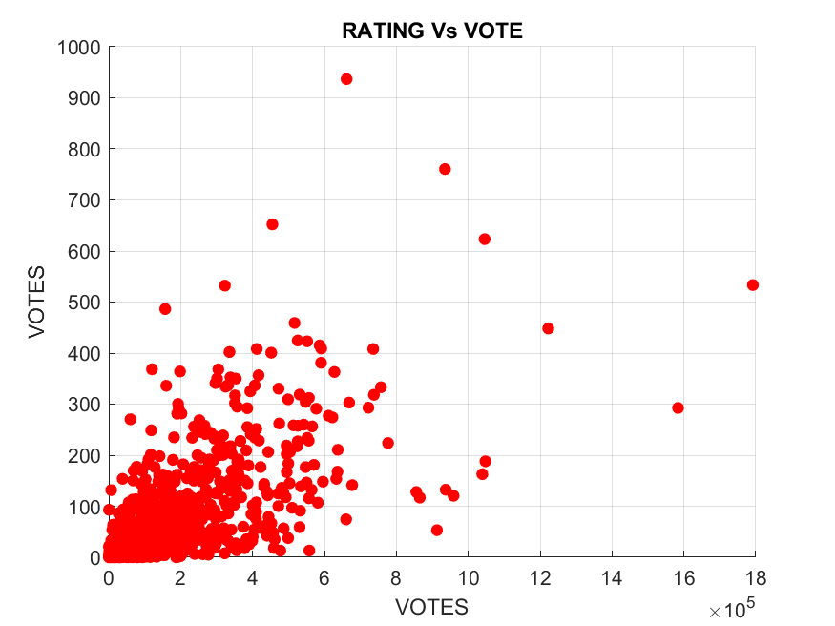

4. LINE PLOT

Table3 = groupsummary(mat,"Rating");

plot(Table3.Rating,Table3.GroupCount,"ys-");

grid on;

title("A PLOT");

xlabel("RATING");

ylabel("NUMBERS");

saveas(gcf,"figure 5 LINE PLOT.png");

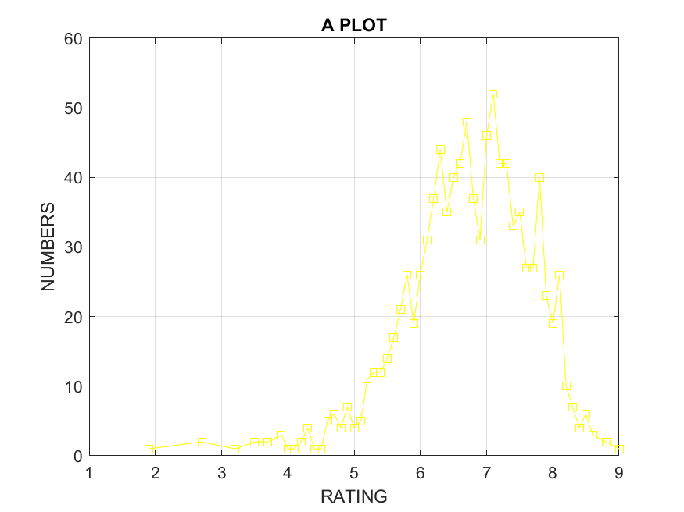

5. HEATMAP

heatmap(mat.Rating);

grid on;

title("HEATMAP RATING");

saveas(gcf," figure 6 HEATMAP.png");

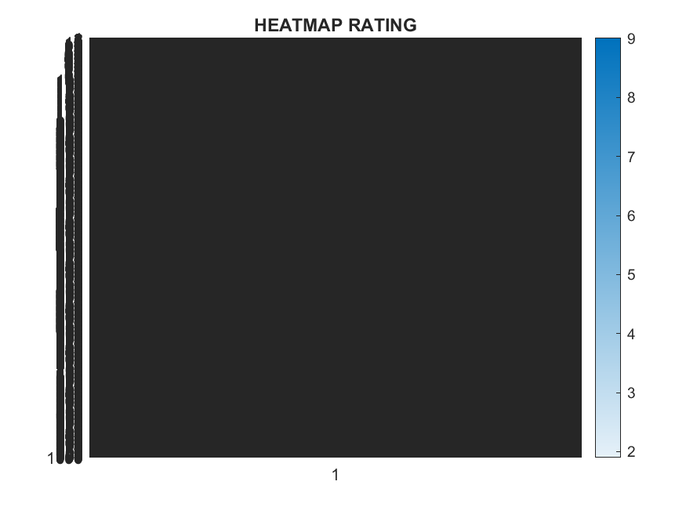

6. 3D SCATTER PLOT

scatter3(mat.Rating,mat.Votes,mat.Revenue_Millions_);

xlabel("RATING");

ylabel("VOTE");

zlabel("REVENUE");

title("3D DATA PLOT");

saveas(gcf,"figure 7 3D PLOT.png");

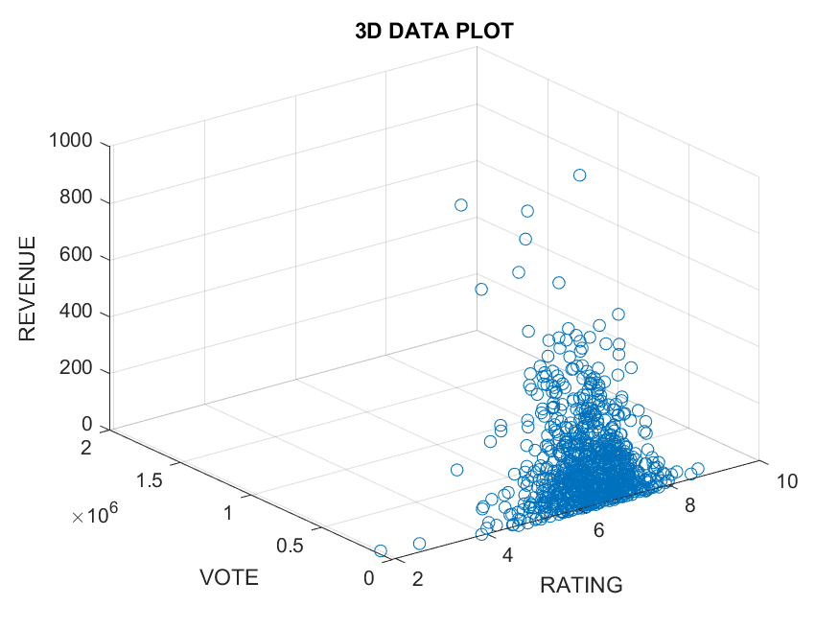

scatter3(mat.Year,mat.Runtime_Minutes_,mat.Rating,"r","filled");

xlabel("YEAR");

ylabel("RUNTIME");

zlabel("RATING");

saveas(gcf,"figure 8 3D SCATTER PLOT.png");

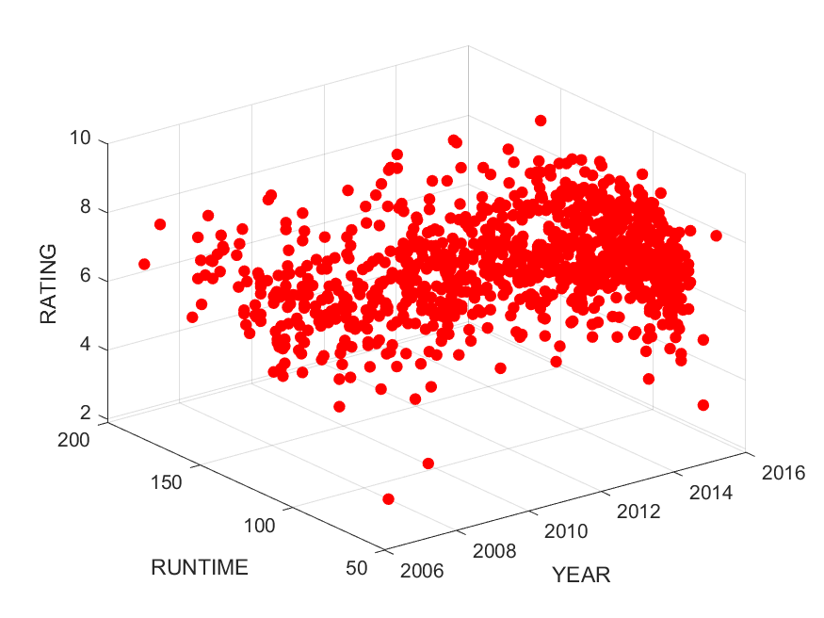

# Question Two;

From the previous question two, utilize all the knowledge from module one to four to describe the different statistical characteristics in your data and ensure to visualize them. Ensure that the different attributes/ data collected per individual is detailed enough to describe them.

# QUESTION TWO SOLUTION;

Question two required us to visualize each member’s statistical data.

Using the reference of exercise two first assignment, we arranged our data to a structural array then to a table array. We spotted out the statistical data and visualized it into different plots.

Below is the code for the MATLAB script we used to achieve the intended outcome of question two

%%Defining struct

members = struct('Name',{},'Age',{},'course',{},'HomeDistrict',{},'Interest',{},'Tribe',{},'Background',{},'FacialRepresentation',{},'Village',{},'Religion',{});

%member1

members(1).Name = 'MUKHOOLI ELIJAH';

members(1).Age = 28;

members(1).course = 'MEB';

members(1).HomeDistrict = 'Mbale';

members(1).Interest = 'Researching';

members(1).Tribe = 'Gishu';

members(1).Background = 'Humble';

members(1).FacialRepresentation = imread("WhatsApp Image 2025-09-10 at 22.25.52_3f4691f9.jpg");

members(1).Village = 'Bugema Cell';

members(1).Religion = 'Pentacostal';

%member2

members(2).Name = 'AUMA DIANA';

members(2).Age = 22;

members(2).course = 'WAR';

members(2).HomeDistrict = 'Oyam';

members(2).Interest = 'Watching';

members(2).Tribe = 'Lango';

members(2).Background = 'Humble';

members(2).FacialRepresentation = imread("WhatsApp Image 2025-09-10 at 22.25.53_d5a71d71.jpg");

members(2).Village = 'Aringolworo';

members(2).Religion = 'Catholic';

%member3

members(3).Name = 'UHURU BRIAN DENISH';

members(3).Age = 21;

members(3).course = 'WAR';

members(3).HomeDistrict = 'Lamwo';

members(3).Interest = 'Video Game';

members(3).Tribe = 'Acholi';

members(3).Background = 'Humble';

members(3).FacialRepresentation = imread("WhatsApp Image 2025-09-10 at 22.25.53_e1b26b1e.jpg");

members(3).Village = 'Okokwene';

members(3).Religion = 'Catholic';

%member4

members(4).Name = 'TUMUHAISE SARAH';

members(4).Age = 21;

members(4).course = 'AMI';

members(4).HomeDistrict = 'Hoima';

members(4).Interest = 'Cooking';

members(4).Tribe = 'Runyoro';

members(4).Background = 'Humble';

members(4).FacialRepresentation = imread("WhatsApp Image 2025-09-10 at 22.25.54_c2db7638.jpg");

members(4).Village = 'Katasiha';

members(4).Religion = 'Anglican';

%member5

members(5).Name = 'NABAWEESI CLAIRE';

members(5).Age = 20;

members(5).course = 'WAR';

members(5).HomeDistrict = 'Mityana';

members(5).Interest = 'Watching animations';

members(5).Tribe = 'Muganda';

members(5).Background = 'Humble';

members(5).FacialRepresentation = imread("WhatsApp Image 2025-09-10 at 22.25.52_3f4691f9.jpg");

members(5).Village = 'Wabigalo';

members(5).Religion = 'Catholic';

%member6

members(6).Name = 'NANDAULA CATHERINE';

members(6).Age = 21;

members(6).course = 'AMI';

members(6).HomeDistrict = 'Buvuma';

members(6).Interest = 'Baking';

members(6).Tribe = 'Muganda';

members(6).Background = 'Humble';

members(6).FacialRepresentation = imread("WhatsApp Image 2025-09-10 at 22.25.55_088b8852.jpg");

members(6).Village = 'Bugaya';

members(6).Religion = 'Bornagain';

%member7

members(7).Name = 'OMARA PASCHAL KELLY';

members(7).Age = 21;

members(7).course = 'WAR';

members(7).HomeDistrict = 'Oyam';

members(7).Interest = 'Singing';

members(7).Tribe = 'Lango';

members(7).Background = 'Humble';

members(7).FacialRepresentation = imread("WhatsApp Image 2025-09-10 at 22.25.58_f33d070d.jpg");

members(7).Village = 'Aringoarum';

members(7).Religion = 'Catholic';

%member8

members(8).Name = 'ENAMU REAGAN EGIMU';

members(8).Age = 21;

members(8).course = 'APE';

members(8).HomeDistrict = 'Soroti';

members(8).Interest = 'Soccer';

members(8).Tribe = 'Itesot';

members(8).Background = 'Humble';

members(8).FacialRepresentation = imread("WhatsApp Image 2025-09-10 at 22.25.54_161b4918.jpg");

members(8).Village = 'Owalei';

members(8).Religion = 'Catholic';

%member9

members(9).Name = 'OLUK CHRISTIAN GLEN';

members(9).Age = 21;

members(9).course = 'WAR';

members(9).HomeDistrict = 'Apac';

members(9).Interest = 'Playing Football';

members(9).Tribe = 'Lango';

members(9).Background = 'Humble';

members(9).FacialRepresentation = imread("WhatsApp Image 2025-09-10 at 22.25.57_28f556bf.jpg");

members(9).Village = 'Akokoro';

members(9).Religion = 'Catholic';

%member10

members(10).Name = 'NAKAWEESA LINNET';

members(10).Age = 21;

members(10).course = 'APE';

members(10).HomeDistrict = 'Mukono';

members(10).Interest = 'Food';

members(10).Tribe = 'Muganda';

members(10).Background = 'Humble';

members(10).FacialRepresentation = imread("WhatsApp Image 2025-09-10 at 22.25.58_5ac3f089.jpg");

members(10).Village = 'Mukono';

members(10).Religion = 'Bornagain';

save("test.mat","members")

T = struct2table(members)

disp(T)

histogram(T.Age)

title("Distribution of Age")

xlabel("Age")

ylabel("Frequency")

grid on

saveas(gcf,"figure1.jpg")

barh(T.Name,T.Age)

title("Age Distribution")

xlabel("Age")

ylabel("Name")

grid on

saveas(gcf,"figure2.jpg")

boxplot(T.Age)

title("DISRIBUTION AGE");

ylabel("AGE")

grid on;

saveas(gcf,"figure_3.jpg")

pie(T.Age,T.Name)

title("PIE CHAT")

saveas(gcf,"figure4.jpg")

**Various visualization of data**

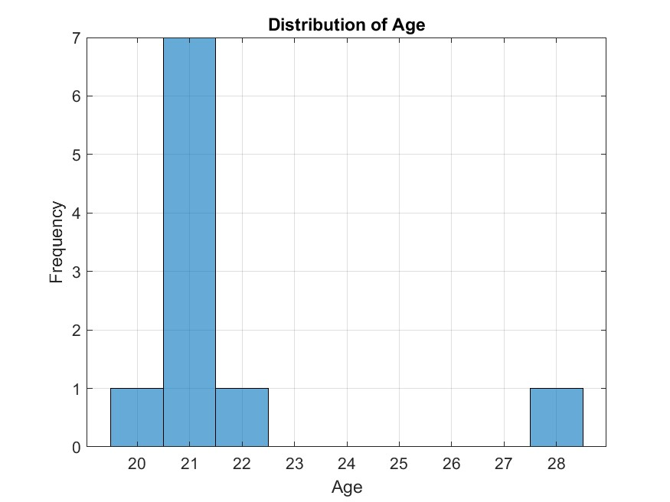

Figure1 shows a histogram

The graph shows how ages are distributed across the each member.

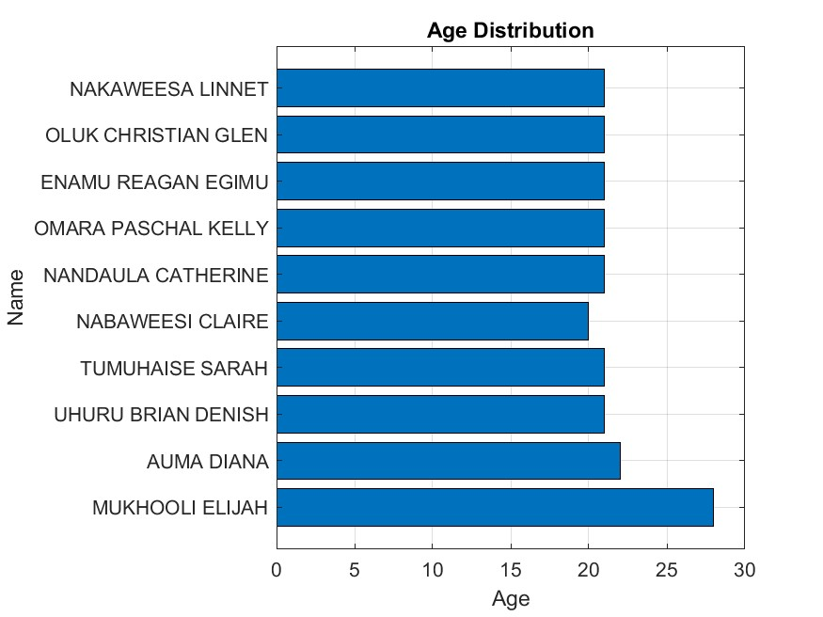

Figure2 shows a bar graph

The bar graph above plots each member’s name on y-axis and their corresponding age on x-axis

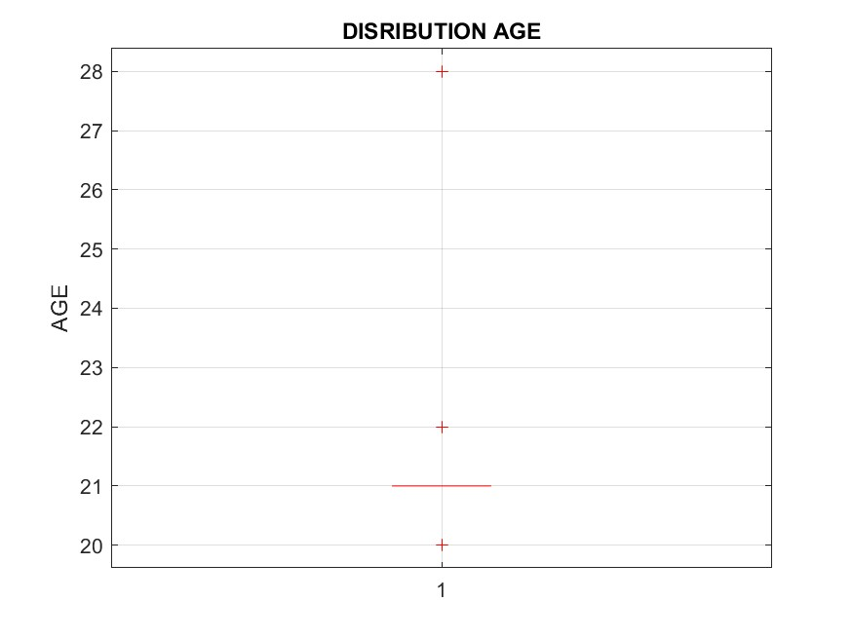

Figure3 shows a box graph

This creates a box-and whisker plot for ages

It summarizes the distribution of ages by showing the minimum and maximum values, median age, the quartiles.

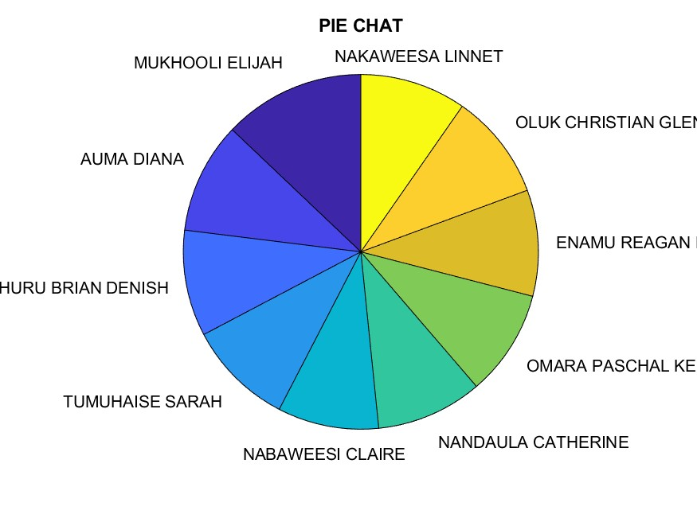

Figure4 shows a pie chat

The pie chat shows distribution of members’ age proportions as percentages

## Chapter 3: Conclusion and Learning Experience

Getting the dataset from Kaggle.com was quite a problem because most of them had information which did not meet our goal according to the first question of the first assignment. Using reliable variables, functions to run the code was quite challenging. On completing the assignment, we were able to learn how to retrieve data from Kaggle.com, run codes, visualize them and see the results. To our dismay, not all the codes were programmed rightly, we had challenges of codes running for long and not as programmed. Our dedication and persistence kept us swaying through the hurdles until we had our codes running as programmed.

## Chapter 4: References and Resources

* [kaggle.com](https://www.kaggle.com/) - The primary source for the dataset used in this assignment.
* MATLAB Documentation - Used for syntax and function guidance on readtable(), struct(), and writetable().
* You tube MATLAB tutorials